General information about the crops
Orange (kharif)
Common name -santra
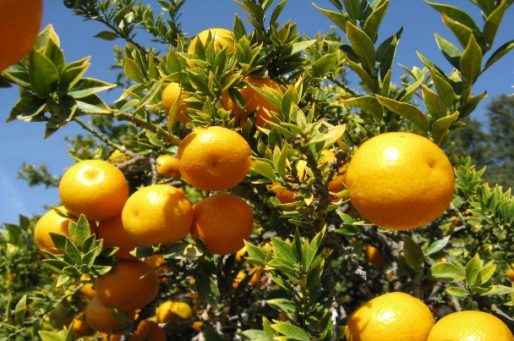
- General
Orange is widely grown citrus fruit of India. It occupies nearly 50% of total area under citrus cultivation. Mandarin, Sweet Orange is commercially grown citrus species in India. Production of Mandarin orange is increasing every year in central and western parts of country. India ranks third in the production of orange after banana and mango fruits. In India, Orange is being grown in Rajasthan, Himachal Pradesh, Punjab and Uttar Pradesh

- Climate
Temp(MIN/MAX)  10-30 | Rainfall(MIN/MAX)  50-60 cm
Sowing Temperature  10-35 | Harvesting Temperature  30-34

- Popular variety with their Yield.
Variety | Yield
Blood red | 70
mosambi | 70

- Land preparation
Land need to be prepare properly for growing seedlings. Land should be ploughed, cross ploughed and leveled. Terrace planting is done on hills. High density planting is possible in hilly areas.

- Sowing- spring season (February to March) and Monsoon season (15 August to October end).

- Seed Rate- Minimum plant density of 110 plant/acre should be maintained
- Fertilizer Requirement gm/tree
Age of crop(year) | urea | ssp
1-3 year | 240-720 | -
4-7 year | 960-1680 | 1375-2400
8 and above | 1920 | 2750

Nutrient requirement gm/tree
Age of crop(year) | nitrogen | phosphorus
1-3 year | 110-130 | -
4-7 year | 440-770 | 220-385
8 and above | 880 | 2750

For 1-3year old crop, apply well decomposed cowdung@10-30kg, Urea@240720gm per tree. For 4-7year old crop, apply well decomposed cow dung@40-80kg, Urea@9601680gm and SSP@1375-2400gm per tree. For eight years and above crop, apply cowdung@100kg, Urea@1920gm and SSP@2750gm per Tree. Apply whole amount of cow dung during December month whereas apply Urea in two parts, apply first of Urea in February, and second dose in April-May month. At time of applying first dose of Urea, apply whole dose of SSP fertilizer. If fruit drop is observed, to control excessive fruit drop, take spray of 2,4-D@10gm in 500Ltr of water. Take first spray in March end, then in April end. Repeat the spray in August and September end. If cotton is planted in nearby field of citrus, avoid spraying of 2, 4-D, instead take spray of GA3.

- Weed Control
Weed can be controlled by hand-hoeing and also controlled by chemically, use glyphosate@1.6litre per 150 litre of water. Use glyphosate only on weeds not on crop plants.
- Irrigation
Irrigation requirement of orange is very high due to its evergreen nature throughout the year. Amount of irrigation also depends upon the type of soil. Proper irrigation should be provided at the time of flowering, Fruit set and Fruit development. Water logging should be avoided. Irrigation water should be free from salts.
- Plant protection
Citrus Psylla: These are Juice sucking pests. Damage is mainly caused by Nymphs. It injects a plant toxin liquid which burns foliage and skin of fruit. Leaves curl and fall o prematurely. It can be controlled by pruning of diseased plants, burning them. Spraying of Monocrotophos-0.025% or carbaryl- 0.1% can also be helpful.

Leaf miner: Larvae inside the upper or lower surface of young and newly emerged leaves are curled and look distorted. Young trees show a reduction in growth due to leaf miner. Best management for leaf miner is to leave it alone and let the natural enemies to feed upon them and parasitize their larvae. It can also be controlled by spraying Phosphomidon @1ml or Monocrotophos @1.5ml per 3-4 times fortnightly. Pheromone traps are also available for detecting leaf minor moths
Orange shoot borer -Freshly hatched larvae bore into twigs. They feed upon soft tissues. This insect feed upon trees in the day hours. Aected plants tend to lose its vigor. It is very serious pest of citrus plant. It can be controlled by destroying the aected branches. Kerosene oil/petrol injection can also help to control this insect.

Citrus Canker: Plants have lesions on stems, leaves and fruits with brown, water-soaked margins. Citrus canker bacteria can enter through plant’s stomata into the leaves. Younger leaves are highly susceptible. Lesions oozes bacterial cells which can be dispersed by blowing wind to healthy plants in area. Contaminated equipment tends to spread disease to healthy plants. Bacteria can stay viable in old lesions for several months. It can be detected by appearance of lesions. It can be controlled by cutting of eected branches, twigs. Spraying of Bordeaux mixture @1%. Aqueous solution of 550ppm, Streptomycin Sulphate is also helpful in controlling citrus canker.

- Harvesting-
On attaining proper size, shape along with attractive color having TSS to Acid ratio of 12:1, kinnow fruits is ready for harvest. Depending upon variety fruits are generally ready for harvesting in Mid- January to Mid- February. Do harvesting at proper time as too early or too late harvesting will give poor quality.

- Storage-After harvesting, wash fruits with clean water then dip fruits in Chlorinated water@2.5ml per Liter water. Then partially dried them. To improve appearance along with to maintain good quality, do Citrashine wax coating along with foam. Then these fruits are dried under shade and then packing is done. Fruits are packed in boxes.

